Announcement without Pictures:
(the following announcement can be used by itself, or as text in a newsletter or social media)

Brothers of Borromeo Vocation Camp (B.B.V.C.)

Young men in grades 6, 7, and 8 are invited to join the Vocation Office and Philadelphia seminarians for B.B.V.C.! Held on April 22, 2023 at St. Charles Borromeo Seminary, B.B.V.C. is a day filled with faith, fun, fellowship and food. For more information and to register, contact the Vocation Office at 610-667-5778 or visit HeedTheCall.org/BBVC.

___________________________________________________________

Announcements with Pictures:

On the following pages are two different sizes of images to be used for advertising Brothers of Borromeo Vocation Camp in your bulletin, newsletter, or around your organization. To download these, right click on the image, and click ‘Save as picture’ and select a location where you would like to save the file. The 4.75 x 4.5-inch image can also be used in social media. Be sure to tag and follow the Vocation Office on Instagram and Facebook, @PhillyPriest!

If you would like a different size announcement, please contact Jillian Minnich, Program Coordinator for assistance at 610-667-5778 or jminnich@archphila.org).

(4.75 x 2 inches):
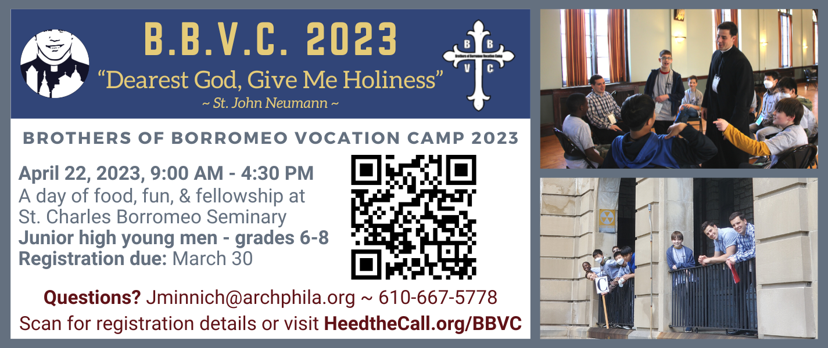

(4.75 x 4.5 inches):
