Bulletin Announcement

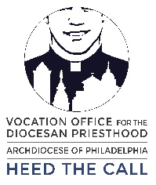
Spend the Summer with the Vocation Office – June and July 2019

This summer, the Vocation Office is offering three exciting camps for high school men. Quo Vadis is a 4-day camp of faith and fun for men entering 9th grade through graduating 12th graders. Join us at Black Rock Retreat in Quarryville this June 24-27.

Philadelphia Catholic Scholars is an exciting exploration into Catholic spiritual and philosophical tradition. High school juniors and seniors earn three college credits from July 8-18 at St. Charles Borromeo Seminary.

Going Deeper allows high school juniors and seniors to gather for a service-oriented 4-day camp. Dive into faith and fellowship at the Spiritual Year House at St. Matthew’s in Conshohocken from July 28 through August 1.

To register for any of these events or learn more information, visit HeedTheCall.org/summer or call the Vocation Office at (610) 667-5778.

Pulpit Announcement

The Vocation Office is inviting high school men to join them for three tremendous camps this summer! These camps combine great talks and service with faith, great food, fun activities, and fellowship. For more information on these camps, ask [Pastor’s name] or see this week’s bulletin.

Social Media Post

The Vocation Office is inviting high school men to join them for camps this summer! These camps combine great activities with faith, good food, fun activities, and fellowship. For more information on these camps, visit HeedTheCall.org/summer or call (610) 667-5778.

