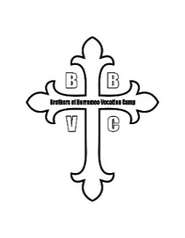Archdiocese of Philadelphia   
Brothers of Borromeo Vocation Camp (B.B.V.C.)

**Saturday, March 22, 2025 – 9:00 AM to 4:30 PM**

**REGISTRATION AND PARENTAL PERMISSION FORM**

**Registration due by Friday, February 28, 2025 ~ Cost $25**

Participant Name:

Date of Birth: Grade: T-Shirt Size (Adult):

Parent/Guardian Cell Phone During Event: ­­­­ School:

Email Address: Parish/Location:

Participant’s Physician: Phone:

Health Insurance Type: Policy Number:

**Please list any conditions (e.g. allergies – food, bees, etc.), other medical problems, or dietary restrictions that should be brought to the attention of chaperones**:

***Recognizing that I as the parent/guardian will always be contacted initially in the event of an emergency, I authorize the following person to act on my behalf if I cannot be reached:***

Name:

Relationship to Participant: Phone During Event:

I grant permission for my son _________________________________________, to participate in B.B.V.C. on Saturday, March 22, 2025 (9:00 am to 4:30 pm) at St. Charles Borromeo Seminary, 1400 Evans Road Ambler, PA 19002. I understand that my son may not leave early or with another person without my written permission.

# Knowing that there will be proper supervision, in case of injury or illness, I will not hold the Vocation Director for the Diocesan Priesthood, the Archdiocese of Philadelphia, St. Charles Borromeo Seminary or any person or persons connected with them liable. My signature below also gives the Vocation Office, the Archdiocese of Philadelphia, and St. Charles Borromeo Seminary permission to use pictures from the day in which my child may appear for promotional materials.

Parent/Guardian Signature:

Parent/Guardian Printed Name: Date:

***Please mail completed form with a check for $25 made payable to the Vocation Office:***

**Office Use Only:**

Received:

Payment Method:

___________­­­­­­­­­­­­­­­­­­­­­­______________

# **Attn: B.B.V.C. 2025**

Vocation Office for the Diocesan Priesthood

Saint Charles Borromeo Seminary

1400 Evans Road

Ambler, PA 19002

***If you prefer to pay by credit card, a 3% charge will be added to the registration fee.***

***Please call Melissa Kovatch in the Vocation Office at 610-667-5778 to set up your payment.***