Bulletin Announcements
On the following pages are two different sizes of images to be used for advertising Quo Vadis in your bulletin. To download these, right click on the image, and click ‘Save as picture’ and select a location where you would like to save the file.

If you would like a different size bulletin announcement, please contact Jillian Minnich, Program Coordinator for assistance at 610-667-5778 or jminnich@archphila.org).

Bulletin Announcement (4.75 x 2 inches):

Bulletin Announcement (4.75 x 4.5 inches):

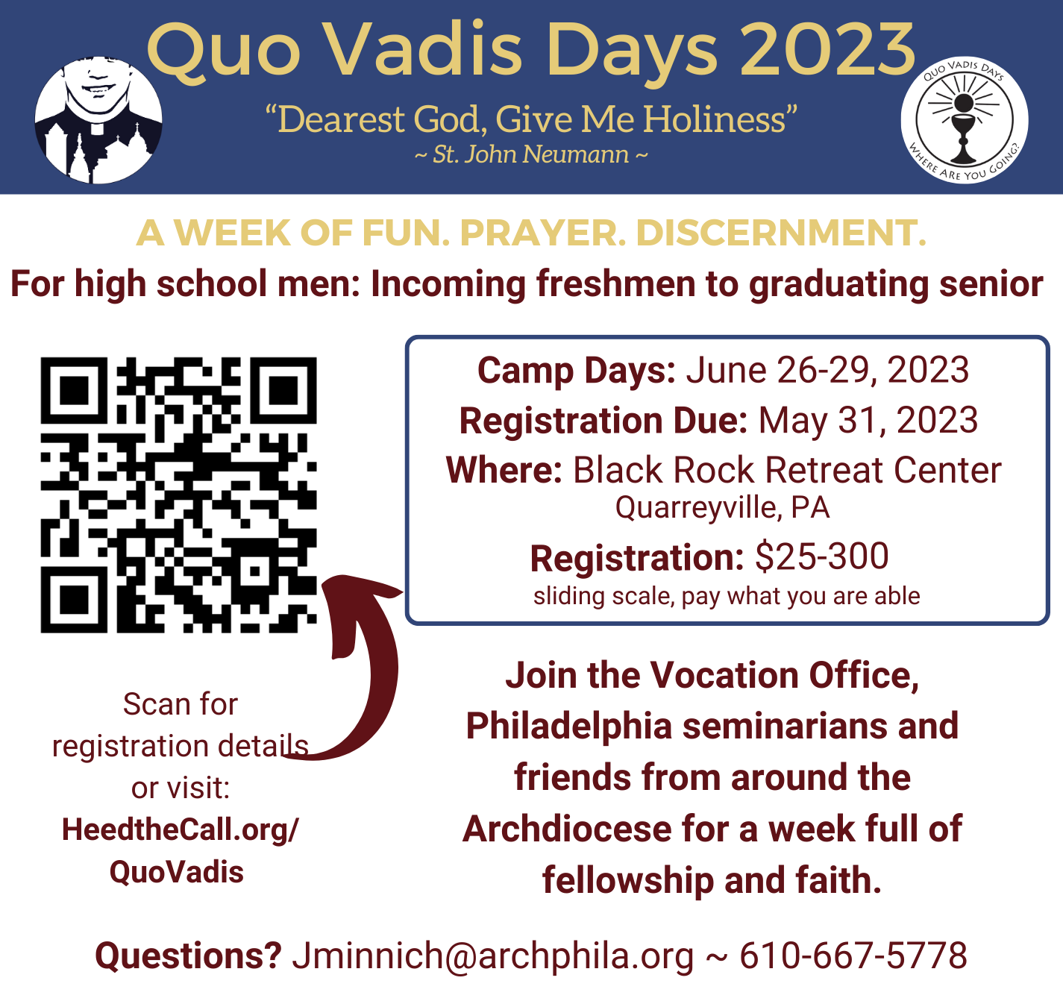

Pulpit Announcements
Below are pulpit announcements to be used in conjunction with the bulletin announcements. These are separated by month and can be copied and modified with the Pastor's name or additional information.
To be used between January and February:
Registration for Quo Vadis 2023 is now open to high school-aged young men! Quo Vadis is a week filled of fun, prayer & discernment and takes place from June 26 - June 29. For more information, see today’s bulletin or see [INSERT PASTOR’S NAME HERE].

To be used between March & April:
High school-aged men are invited to join Philadelphia seminarians, and other young men from around the Archdiocese for Quo Vadis Days! From June 26 - June 29, the Vocation Office for the Diocesan Priesthood will host a week of fun, prayer, and discernment for incoming freshman to graduating seniors! Please see today’s bulletin or see [INSERT PASTOR’S NAME HERE] for more information.

To be used for the month of May:
This month is the last chance for high school men to register for Quo Vadis Days! Don't miss out on a week of faith and fellowship and register today before it's too late! For more information please see todays bulletin or see [INSERT PASTOR’S NAME HERE]. Registration for Quo Vadis Days closes on May 31.

Sample Prayer Intention
For all young men attending Quo Vadis Days and all those leading the retreat, may they grow in fraternity and fellowship and be led to further discipleship in Christ. Let us Pray to the Lord

